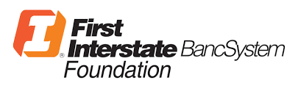

Grants by Girls Application________________
Directions: Please submit completed application, no more than 4 pages total, to Maura Riley (mriley@allthrive.com) no later than February 1, 2019. Recipient(s) will be notified by March 1, 2019. The grant amount is $1,000, and a report will be due by December 1, 2019 telling us about the success of your project.

Contact Information____________________________________________________________
Organization Name:
Tax ID Number:
Contact Person:
Mailing Address:
Phone Number:
Email Address:

Tell us about your project?_______________________________________________________________
What is the name of your project?

Please give us an overview and timeline of how this project will be carried out?

What are the goals of your project (please use S.M.A.R.T. goals)?

What community need will this project address? How will this project address that need?

How does this project engage or serve local girls or women?

Do you have any community partners? If so, who and what capacity will you work with them in?
Budget_______________________________________________________________________________
Please fill in the following table with an itemized budget of the funds will be spent.
ITEM | AMOUNT
TOTAL:

Signature_____________________________________________________________________________

Contact Person Signature: _______________________________________________________________
Date: __________________________

